**Brian F. Riser Memorial Golf Tournament**

Sponsored by Irishtown Fire Company

August 9, 2025 at The Bridges Golf Course

Registration opens at 7:00 AM

Tournament begins at 8:00 AM

4 Man Scramble

**$300 per team ($75/player) – Includes greens fees, cart, food & prizes**

***Proceeds to benefit Irishtown Fire Company with a donation made in honor of Brian Riser to the American Cancer Society***

**Prizes: 1st $400 2nd $300 3rd $200**

**Pot of Gold**

**Closest to Pin & Longest Drive**

**Pulled Pork Lunch following the tournament at Irishtown Fire Company**

**50/50 and games of chance**

**Door Prizes**

Team Captain Name

Address

Phone email

Player # 2 Name

Player # 3 Name

Player #4 Name

Registration is open until 8/1/2025 – Make checks payable to Irishtown Fire Company and mail to 934 Irishtown Rd, New Oxford, PA 17350

For more information contact:

Irishtown Fire Company – 717-624-4141 or contact/message on facebook@IrishtownFireCo14

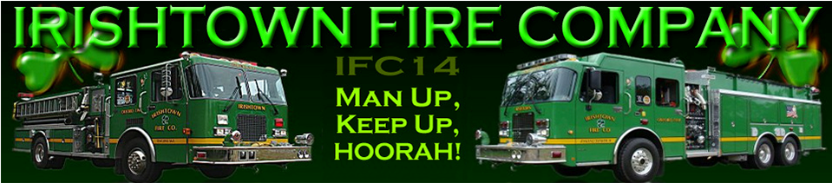

** Free range balls for the driving range prior to the tournament **